Report Lab02

Student name: Ngô Văn Đông

Student ID: 20235486

1. Use case diagram

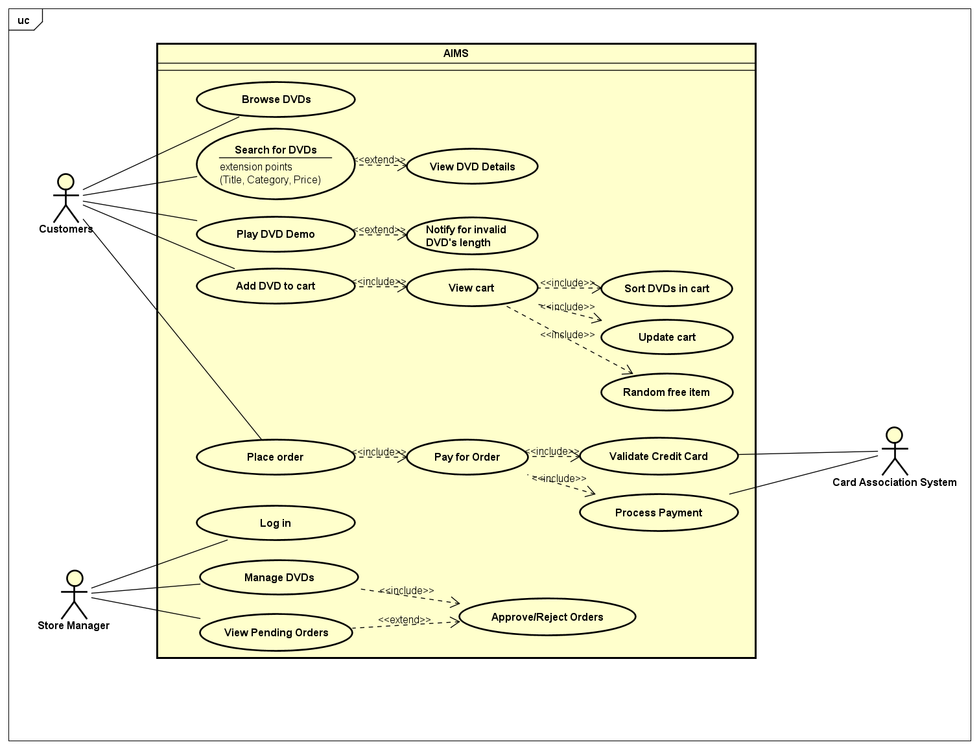

1. Class diagram:

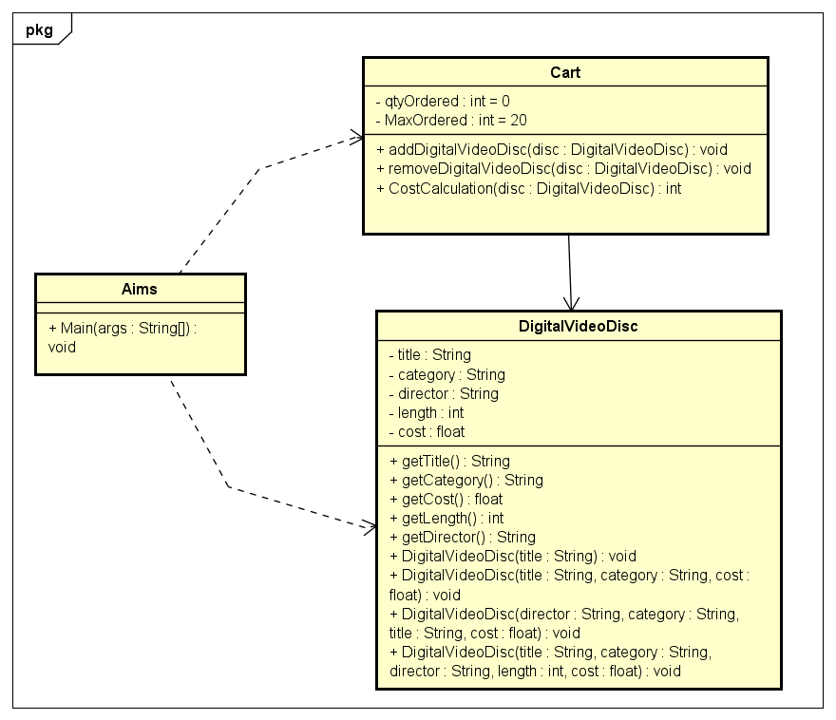

1. Reading assignment:

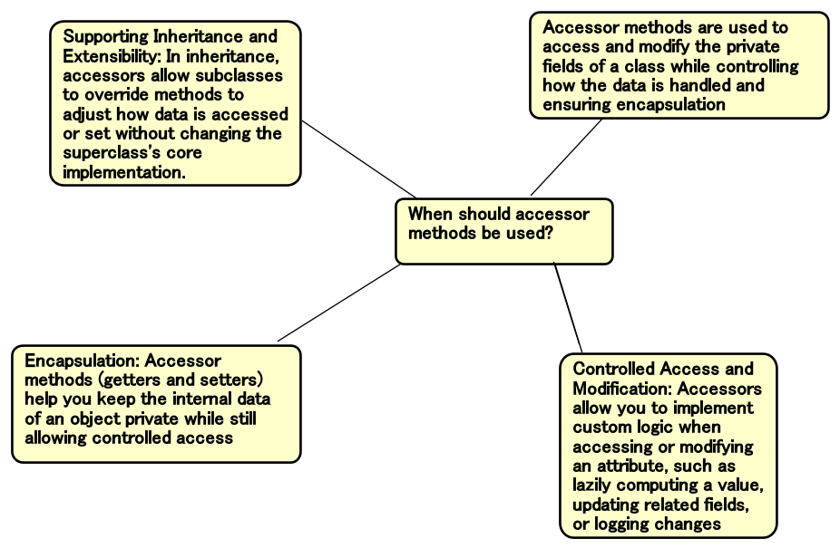

1. Answer the questions:

Question: If you create a constructor method to build a DVD by title then create a constructor method to build a DVD by category. Does JAVA allow you to do this?

Answer: No, because they have the same signatures.